Question: What is the best place to look for the central idea of an informational text?

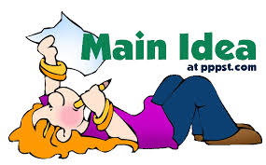

Answer: Most of the time, the central idea can be found at the beginning and the end of the text. However, sometimes you have to infer the central idea by using all of the details.

Question: What happens in the rising action of a plot?

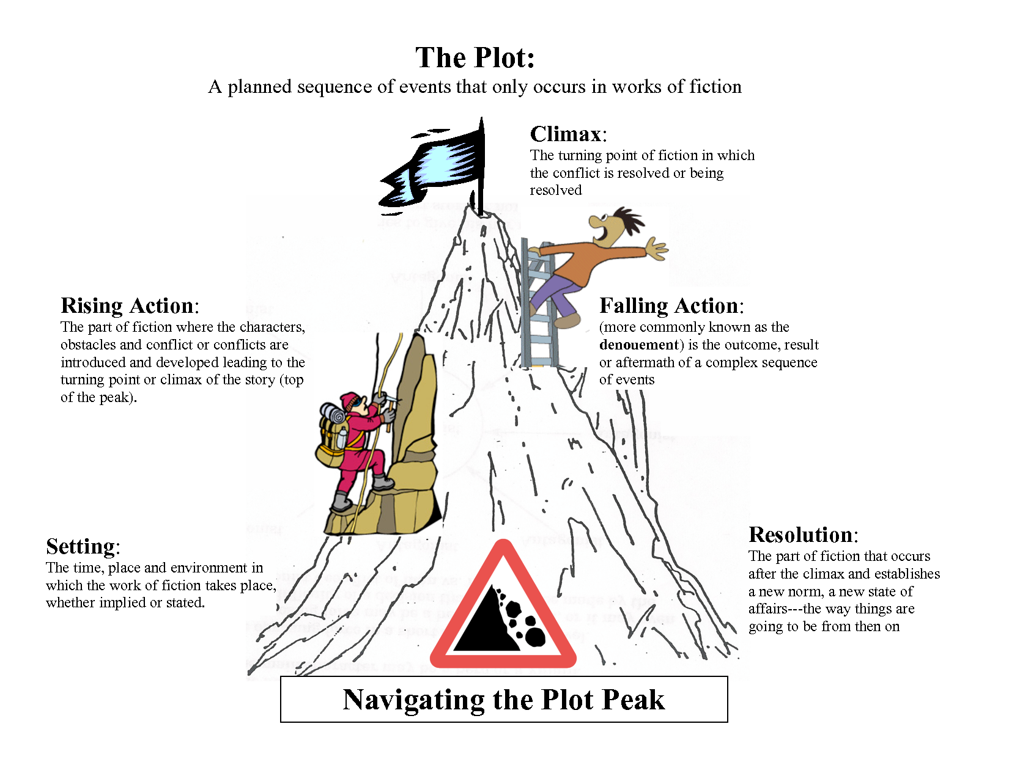

Answer: The conflicts/tension builds.

Question: What happens in the resolution of a plot?



Answer: All loose ends are tied up. The conflict is resolved.

Question: What happens in the falling action of a plot?



Answer: The conflict begins to be resolved. We see what happens as a result of the climax.

Question: How can the setting contribute to the conflict of a narrative?

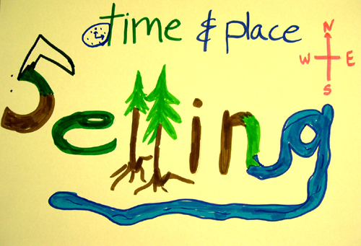

Hint: What is a setting? What is a conflict?

Hint: What if someone is in the woods in the middle of the night?

Answer: The setting can contribute to the conflict if it creates more problems for the characters. For example: A character’s car breaks down in the middle of nowhere. The problem of the car breaking down is much worse because the character is not around anyone. If the character was in town, it would not be as big of a problem. In “Boar Out There,” the little girl would not have had the conflict she had if she had been in town.

Question: What should never be included in a summary?

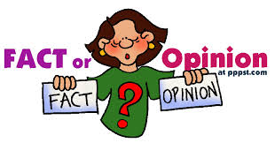

Hint: A summary should only contain facts.

Answer: An opinion should never be included in a summary. An opinion is what you think about the topic.

Supporting Detail

Supporting Detail

Supporting Detail

Overall Central Idea

Question: How do you determine what details should be included in a summary?

Answer: You should determine which details are most important. Make an outline by going through each paragraph. Take the main idea of each paragraph and add it to your outline. You should never include details that do not directly support the overall central idea.

Question: In the story, “The Three Little Pigs,” two pigs are lazy and build their houses out of straw and sticks, but the third pig builds his house out of bricks. The lazy pigs get their houses blown away by the big bad wolf. What is the theme of this story?

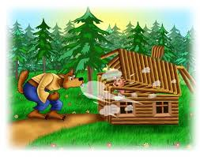

Possible Answers: Hard work pays off; do things right the first time around; be prepared

Question: What does foreshadow mean?

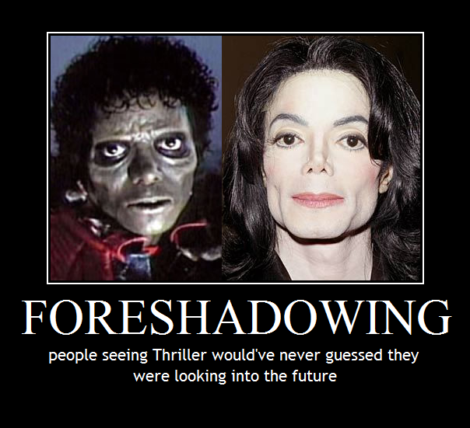

Hint: What does the prefix “fore” mean?

Answer: Authors use foreshadowing to hint at events that happen later in the story.

Question: Miss White has recess duty. Jacob finds a frog, picks it up, and runs over to show it to Miss White. Miss White screams, jumps, and runs as fast as she can into the school. What can you infer about Miss White? How do you know?

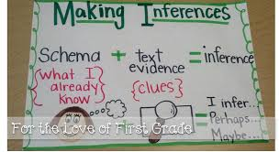

Answer: We can infer that Miss White is afraid of frogs because she “screams, jumps, and runs as fast as she can into the school.”

Question: What is the sequence of events?

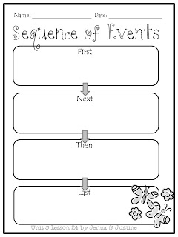

Answer: The order in which the events in the story take place. The sequence of events makes up the plot.

Question: Give three words or phrases that provide information about the sequence of events.



Possible Answers: First, Second, Next, Later, Then, In the morning, That night, After lunch, At noon, Before they left, When the phone rang, etc. Any words/phrases that tell you “when” information.

Question: Where should you look for words and phrases that give you information about the sequence of events?



Answer: The words and phrases that give information about the sequence of events are also known as transitions. You should first look in the first sentence of paragraphs. However, they can be found in the middle of paragraphs as well.

Question: What is the central idea of a text?

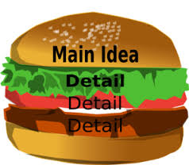

Answer: The central idea of a text is also known as the main idea. The central idea of a text is what the text is mostly about, or what the thesis is. You can figure this out by figuring out the topic and asking yourself, “What about it?”